# UNIT- 1: Internet Basics

**UNIT STRUCTURE**

1.0 Objective

1.1 Concept of Internet

1.2 Evolution of internet

1.3 Basic concepts

1.4 Communication on the Internet

1.5 Internet Domains

1.6 Internet Server Identities

1.7 Establishing Connectivity on Internet

1.8 Client IP Address

1.9 TCP/IP and its Services

1.10 Web Server

1.11 Web Client

1.12 Domain Registration

1.13 Summary

1.14 Question for Exercise

1.15 Suggested Readings

# 1.0 Objective

Defense Advanced Research Project Agency (DARPA) of US initiated a research activity that eventually developed as a system for global data commmunication service known as the Internet. The internet, today, is being operated as a joint effort of many different organizations. In this unit, you will learn the basic concepts related to internet as well as the various mechanisms and technologies involved in the deployment of the internet. Upon completion of this unit, the readers shall be aware of the basic terms and terminologies, involved devices and mechnaisms and the applications of the Internet.

# 1.1 Concept of Internet

The Internet is “the global system of interconnected computer networks that use the Internet protocol suite (TCP/IP) to link devices worldwide.” It has changed the way we do our daily chores. The usual tasks that we perform like sending an email, looking up train schedules, social networking, paying a utility bill is possible due to the Internet. The strucure of internat has become quite complex and it cannot be reperented as it is changing instanteniously. Every now and then some resources are being added while some are being romvwd. Internet comprises of various networks that include public, private, government, business, and academic sectors linked together using different electronic technologies.It interconnects global networks with local and vise-versa. The resources of Internet range in both information(including digital documents like image, video, text etc.) and services (including informatio sharing, email, video conferencing) domains.

Though the terms *Internet* and *World Wide Web* are used interchangeably in lay man terms they are not the same. It is common practice to say "*going on the Internet*" whenever we open any web page on a browser. However, the World Wide Web or *the Web* is one of the most popular

Internet services available. The Web is a collection of interconnected documents (web pages) and other web resources, linked by hyperlinks and URLs. It uses HTTP as an underlying protocol for information transfer which is one of the several other protocols available in networking theory.

# 1.2 Evolution of Internet

The Defence Department of US, in 1969, funded a research project for developing a robust network that should be resilient to even bombing. The main objective was to develop a network that should be secure and robust enough to withstand even a nuclear attack. This project was named as the ARPANET. The idea was to have a distributed network in order to avoid attacks on the central authority. This led to the development of Local Area Network (Local Area Network) and workstations equipped with the ability to connect to the Ethernet. These local area networks were eventually connected to the ARPANET. The distributed aspect of the ARPANET catalysed the rapid evolution of the ARPANET over the next decade. Initially, ARPANET used National Control Protocol (NCP) as the standard set of rules defining the communication between the computers connected to ARPANET. However, owing to the rapid development of the information technology, NCP was replaced by the Transmission Control Protocol/Internet Protocol (TCP/IP). The TCP protocol fragments the messages into packet streams at the source and performs reassembly of these packets at the destination. The transmission of these packets from source to destination is handled by the IP. The IP protocol takes care of the addressing conventions and ensures the delivery of the packet at the destination across multiple nodes or even multiple networks. The agile nature of the TCP/IP protocol in handling the communication across multiple heterogeneous networks attracted the other networks to connect to the ARPANET and employ TCP/IP as their underlying communication protocol. Eventually, the ARPANET developed into a large network of networks and is now called as ‘Internet’.

# 1.3 Basic Concept

**1.3.1** **What is the Internet?**

The Internet is a global collection of computer networks that are linked together by devices called routers and use a common set of protocols for data transmission known as TCP/IP (transmission control protocol / Internet protocol). The primary purpose of the Internet is to facilitate the sharing of information. There are many different tools used on the Internet to make this possible. Some of the more common tools include email, list servers, newsgroups, telnet, gopher, FTP, and the World Wide Web. Probably the most popular of all Internet tools is the World Wide Web.

**1.3.2** **What is the World Wide Web (WWW)?**

WWW stands for World Wide Web. A technical definition of the World Wide Web is − All the resources and users on the Internet that are using the Hypertext Transfer Protocol HTTP. The World Wide Web is the universe of network-accessible information, an embodiment of human knowledge. The World Wide Web is a way of exchanging information between computers on the Internet, tying them together into a vast collection of interactive multimedia resources. It is a hypertext interface to internet information resources.

**Internet** and **Web** is not the same thing: Web uses internet to pass over the information.

## 1.3.3 Basic WWW Concepts

The World Wide Web is a way of exchanging information between computers on the Internet, tying them together into a vast collection of interactive multimedia resources. It is a hypertext interface to internet information resources.

### 1.3.3.1 HTTP

HTTP is the short form for Hypertext Transfer Protocol. An example of the standard URL is http://www.google.com. The prefix http in the URL designates the protocol being used for communication. The HTTP protocol is used to access hypertext documents on the World Wide Web.

### 1.3.3.2 URL

URL refers to Uniform Resource Locator. URLs are used as the address of the documents available on the World Wide Web. A URL is the fundamental identifier of any resource available on the web e. g., hypertext pages, images, and sound files. The standard format of a URL has been specified as –

protocol://hostname/other_information

A protocol is, basically, a specification of the flow of information in a network. The protocol required for accessing the resources available on the web is called Hyper Text Transfer Protocol (HTTP). Other protocols supported by the web browsers include telnet, FTP, Gopher, etc. The name of the protocol is followed by a colon, two forward slashes, and then the hostname. The hostname refers to the computer having the requested resource. Hostname is followed by a single forward slash and links to subdirectories or any particular file. The path to the directory holding the requested file or resource may contain single forward slashes.

#### 1.3.3.3 Website

Website refers to a collection of web pages usually written in markup language. For example:

www.google.com refers to the website of Google having ‘com’ as the domain name. Websites can be understood as a location on the World Wide Web that holds the resources which people can request when required. The first or the initial page of any website is known as the home page of that particular website.

#### 1.3.3.4 Web Server

Websites are usually hosted on a computer which is known as a Web server. These servers should require constant connectivity with the internet so that the resources stored by them can be accessed from anywhere in the world. A web server is provided with a unique address which is required to access the contents of the server. The unique address is the identifier for the server and is termed as IP Address. These IP Addresses comprise of a series of four numbers separated by dots or periods. Each number lies between the range of 0 – 255, for example: 192.168.1.1. IP address of the web server is also required when the URL of the website hosted on that server is registered on the World Wide Web.

#### 1.3.3.5 Web Browser

Web Browser is a software required to access the resources available on the World Wide Web. Hence, in order to access any website web browser is required. Examples of web browsers are: Microsoft Internet Explorer, Google Chrome, Mozilla Firefox, Netscape Navigator, etc. Navigating through the pages of a website is termed as web browsing or surfing.

### 1.3.3.6 ISP

ISP is the short form for Internet Service Provider. They are basically the organizations responsible for providing internet connections to the subscribers. Several ISPs also provide space on their web servers for hosting website of the subscribers.

### 1.3.3.7 HTML

HTML refers to Hyper Text Markup Language. It is the development language of the websites available on the web. HTML can be understood as a subset of SGML (Standard Generalized Mark-Up Language).

#### 1.3.3.8 Hyperlink

Hyperlinks can be understood as the access points to other resources of the same or different websites. A hyperlink, sometimes referred to as a link, is a clickable element in an electronic document used to navigate through the linked resources. Typically, you click the hyperlink to access the linked resource. Hyperlinks can be in the form of clickable textual links, icons, buttons, etc.

### 1.3.3.9 DNS

DNS is the short form for Domain Name System. It is used to provide a mapping between the name of the requested website and its IP address. Usually, user remembers the name or URL of a website. When user enters this URL in the web browser, a request is sent to DNS for resolving the entered URL in terms of its IP address. It is the IP address which will be used to locate the requested resource on the web. The mapping of the URL and the IP address a website is usually built during the registration of the domain name.

### 1.3.3.10 W3C

W3C (World Wide Web Consortium) is an international organization comprising of full-time staff, member organizations, and the public for the development of Web standards. The inventor of W3C is Tim Berners-Lee while CEO Jeffrey Jaffe is the CEO of W3C. The main aim of the W3C community is to streamline the development of the open standards for the web. The mission of W3C's is to shape the Web to its full potential. W3C is also one of the main standards body for HTTP and HTML.

### 1.3.3.11 CLIENTS AND SERVERS

A host machine that requests for a resource on the Internet is treated as client. The machine and/or software that manages and replies these requests are called as servers. There are different types of clients like email client, web client, FTP client the corresponding servers are Email server, web server and FTP server.

## 1.3.4 IP Addressing

IP addresses refer to the unique identifier associated with each computer on the internet. These addresses are also called logical address and are used to uniquely identify the communicating entities on the internet. IP addresses are provided and managed by the Internet Protocol at the network layer of the OSI model. IP addresses can be of two types: IPv4 and IPv6.

IPv4 uses a 32-bit address having the **address space** equal to 232. An address space refers to the total number of addresses that can be used by the protocol. Figure 1.2 shows the format of an IPv4 address. Two types of notations have been used to represent an IPv4 addresses:

**Binary notation:** In this notation, the IPv4 address is represented as sequence of 32 bits divided into 4 octets. Each octet refers to eight bits or 1 byte. Thus, IPv4 addresses are sometimes referred to as 4-byte address. Eg: 01110101 10001010 000011101 00000010

**Dotted-Decimal notation:** In order to facilitate easy reading of the IP addresses, they are sometimes written as a sequence of decimal numbers with each byte separated by a period or dot (.). Eg: 192.168.1.10.

These IPv4 addresses employ the concept of classes. The strategy to classify the address space into classes is known as classful addressing. This mechanism splits the address space into 5 classes: A, B, C, D, and E. Examining the first few bits of the binary notation or the first byte of the dotted-decimal notation of the IPv4 address can help in identifying the class to which the address belongs. Table 1.1 shows the different classes of IP.

In classful addressing, an IPv4 address is composed of two parts: network id and host id. The length of these parts vary with respect to the corresponding class. This concept is applicable only for the addresses of class A, B, and C. For the addresses belonging to class A, the first byte corresponds to network id while the remaining 3 bytes refer to host id. Similarly, for class B, the first two bytes refer to network id while the remaining two bytes refer to host id. Finally, for class C, the first three bytes refer to network id while the remaining one byte indicates host id.

It is the responsibility of the Internet Service Provider (ISP) to assign the IP addresses to the computers communicating on the internet so as to identify the country or region from which a computer is connecting to the WEB. The assignment of an IP address may be wither dynamic or static.

Static assignment of IP addresses corresponds to the manual configuration of IP address on the computers. However, a dynamic assignment employs a DHCP server that has been configured to automatically provide IP addresses to the connected hosts.

|  |  |  |  |  |
| --- | --- | --- | --- | --- |
| **Class** |  | **Range** | **Binary Notation** | **Dotted Decimal Notation** |
|  | **From** | **To** |  | **(Range of First Byte)** |
| Class A | 1.0.0.0 | 127.255.255.255 | 0xxxxxxx xxxxxxxx xxxxxxxx xxxxxxxx | 0-127 |
| Class B | 128.0.0.0 | 191.255.255.255 | 10xxxxxx xxxxxxxx xxxxxxxx xxxxxxxx | 128-191 |
| Class C | 192.0.0.0 | 192.255.255.255 | 110xxxxx xxxxxxxx xxxxxxxx xxxxxxxx | 192-223 |
| Class D | 224.0.0.0 | 224.255.255.255 | 1110xxxx xxxxxxxx xxxxxxxx xxxxxxxx | 224-239 |
| Class E | 240.0.0.0 | 240.255.255.255 | 1111xxxx xxxxxxxx xxxxxxxx xxxxxxxx | 240-255 |

Table 1.1: IP address classes

A Router has more than one IP address because router connects two or more different networks. But A computer or host can only have one and a unique ip address. A routers function is to inspect incoming packet and determine whether it belongs to local network or to a Remote Network, if a local packet is determined then there is no need of routing and if a Remote packet is determined then it will route that packet according to the routing table otherwise the packet will be discarded. Figure 1.1 shows the format of an IPv4 Address.

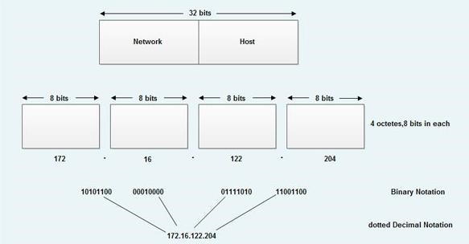

Figure 1.1: IPv4 Address Format

# 1.4 Communication on the Internet

TCP/IP is the only protocol used to send data all around the Internet. TCP/IP is actually two individual sections, (TCP) a set of communication protocols and (IP) a unique address. Every machine connected to the Internet must have an address by which it can be located on the Internet. This is called the IP address of the machine. For the Internet to function smoothly, no two machines can have the same IP address. Hence each machine connected to the Internet must have a unique IP address, which identifies that machine.

The Internet is a worldwide network of networks. As the Internet grew over the years it became increasingly important to have a governing body, which allocated unique IP addresses to organizations linked to the Internet. An international body called InterNIC, located in the USA, is responsible for registering and assigning unique IP addresses to organizations wishing to manage networks, which will be part of the Internet. A unique IP address therefore points to an actual computer connected via a gateway to the Internet. This computer is known as a Domain i.e. a place where information is available. This is a Physical Domain on the Internet.

Conceptually, a Server, which has a permanent IP address (i.e. *a Physical Domain*), can provide the following:

* A gateway to other computers to access the Internet
* Information for Internet clients to read
* A physical location on which *several* Virtual Domains can be hosted

In many cases, when a Web Site provides Internet clients information to read, the site is mounted as a Virtual Domainon an Internet Server, which is its (*host*)Physical Domain.

*Virtual Domains* are identified by a name (e.g. www**.**microsoft**.**com). Just like a *Physical Domain* needs tohave a unique IP address, *Virtual Domain Names* also need to be unique on the Internet. All *Virtual* *Domain Names* must be registered with InterNIC. One Internet Server may host several virtual domains. Virtual domains can be conceptualized as sub directories on an Internet server’s hard disk drive. The information that Internet clients wish to read would be Files within the sub directory.

When an Internet client connects to an Internet server some software running on the Internet server must respond to the Internet client’s request for information. The software that runs on an Internet server and responds to an Internet client’s request for information is called Web Server software. An Internet Web server responds to an Internet client’s request for information by going to a specific sub directory on its hard disk and forwarding a pre-determined file to the Internet client for the first time. Further, the Web server forwards files to the client depending upon their corresponding requests. Traditionally, this sub directory on the Internet server is ‘wwwroot’ and the file automatically picked up and passed to the Internet client for the first time is traditionally called ‘*index.html*’.

## 1.4.1 Ways to Communicate

Growth of mankind began with the advent of communication. We share information, when we are communicating. Sharing of information can be done locally or remotely. Between individuals, generally face to face communication is considered as local communication, whereas communication which takes place over distance comes under remote communication. The term *telecommunication,* which includes telephony, telegraphy, and television, means communication at a distance *(tele* is Greek for "far").

Data is the information presented in whatever form is agreed upon by the parties creating and using the data. The exchange of data between two devices via some form of transmission medium (i.e. wire cable etc.) is known as data communications. To occur data communication, the communicating devices must be part of a communication system which made up by combining hardware (physical equipment) and software (programs). A data communication system is effective if it has the following four fundamental characteristics.

* Delivery: Data must be delivered to the right destination by the system. The Data must be received only by the intended device or user.
* Accuracy. The accurate data must be delivered by the system. Data which have been changed during transmission and left uncorrected are unfeasible.
* Timeliness. The delivery of data must be on time by the system. If the data is not delivered on time then that data is useless. In the case of video and audio, timely delivery refers to delivering data in the same order as they are produced, and without significant delay. This kind of delivery is known as *real-time* transmission.
* Jitter. The variation in the packet arrival time is referred to Jitter. It is the uneven delay in the delivery of audio or video packets. For example, let us assume that video packets are sent every 3D ms. If some of the packets arrive with 3D-ms delay and others with 4D-ms delay, an uneven quality in the video is the result.

There are several ways to communicate over the internet. Some of them are as following.

### 1.4.1.1 Email

Electronic mail (E-mail) is one of the most famous internet services. In earlier days of the internet, electronic mail sent short and consist only text messages. People could exchange messages in a fast way. Now-a-days in e-mail, messages can consist text, audio, images and video. It provides facility to send one message to one or more recipients. Users can compose, read and send messages through E-mail.

### 1.4.1.2 Instant Messaging

To send real time messages from one user to another, Instant Messaging or IM is used. One user types a message that is conveyed over a network and received by the other user. A specific program (i.e. Yahoo Messenger or Windows Live Messenger etc.) is used for Instant messaging between two or more people

### 1.4.1.4 Social Networking

Social networking is an important way of communication. Users can connect and communicate to each other using it. Users can make new friends, find users of similar interest and reconnect with old friends on Social networking websites or applications. Firstly, users need to create a profile on these websites and customize the privacy policy according to their needs (i.e. who can see his/her photos, send friend request or post on his/her timeline etc.). Facebook, Myspace, Twitter, Instagram etc. are the popular social networking applications.

### 1.4.1.5 Forums

An online discussion site where people can do conversations in the form of posted messages is known as an Internet Forum or Message Board. In Forums, they have a specific set of jargons associated with them. For example: a single conversation is known as a “thread” or topic. A discussion forum has a hierarchical or tree-like structure. In a forum, there can be a number of sub forms, each of them may contain various topics. Any new discussion within a forum’s topic is known as thread and as many people as want can reply. It depends on the Forum’s setting that users can be anonymous or need to register with the forum and to post messages, they need to log in. Most of the Forums allows users to read existing messages without log in.

### 1.4.1.6 Audio Conferencing

Audio conferencing is used to connect multiple called parties which are located at different locations on a single audio conference call. Two or more people can be involved in an audio conference call at the same time. Audio conference call can be conducted either through the internet or telephone line. Devices (i.e. phones or computers) which allows sounds to be sent and received are used for audio conferencing. Audio conferencing needs speakers and microphones both. For listening purpose, only speakers are needed. But for speaking purpose microphones are also required.

### 1.4.1.7 Video Conferencing

People are allowed to communicate with one another in real time interactive audio/video. Videoconferencing is an example of real time interactive audio/video in which people are allowed to communicate visually and orally.

In videoconferencing, system is full-motion, two-way, video/audio system which allows two or more humans to communicate with each other which is located at different places. Videoconferencing is usually used in business meetings, distance learning and web-based courses. To make video conferencing success, participants should be able to see, hear and use meeting tools anyway either they are in the same room or across the other side of the world. Live broadcast of lectures and seminars are provided by colleges and universities to some of their students who are not able to travel to class sites. In business meetings, videoconferencing is useful for employee training, group work or to introduce a new product or service.

# 1.5 Internet Domains

Machines on the internet are uniquely identified using their corresponding IP addresses. Similarly, the names assigned to the computers must be unique to avoid ambiguity. A **Namespace** refers to the mapping between the names of the machine and their corresponding IP address. Namespaces can be organized in two ways:

Flat Name Space: This indicates the direct mapping of the IP address to the complete name of the machine. Names are simply a series of characters having no specific structure.

Hierarchical Name Space: In this name space, every name is composed of several parts. The first component may refer to the nature of organization, second may indicate name of organization, third may denote the department in the organization, and henceforth.

Hierarchical name space requires **domain name space** which is an inverted tree structure with each level corresponding to a component of the name space. The complete tree shall have only 128 levels, where level 0 refers to the root. Figure 1.2 shows the structure of DNS.

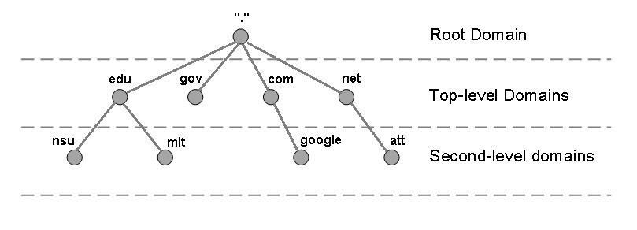

Figure 1.2: Domain Name Space

A domain refers to a sub tree of the domain name space, as shown in Figure 1.3. The domain name of the root of the sub tree will be the name of the domain. A domain can be further subdivided into subdomains.

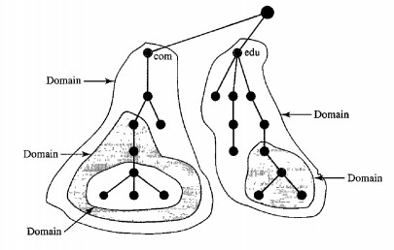

Figure 1.3: Domains

In the context of the Internet, the domain name space (tree) can be classified as:

1. Generic domains
2. Country domains
3. Inverse domains

**Generic Domains:** Generic domains identify the registered hosts as per their general capabilities. Each node of a such a tree refers to a domain which serves as the index for the domain name space database. Figure 1.4 shows structure of Generic Domains

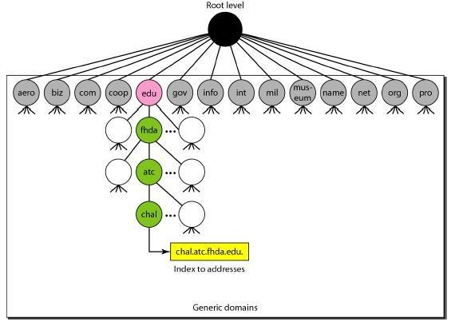

Figure 1.4: Generic Domains

**Country Domains:** Country Domains employ abbreviations of the country. The abbreviations are limited to two characters, e.g. *In* for India. Further labels may refer to the specific organization or other national designations. Consider the following country domain: anza.cup.ca.us. This refers to De Anza College in Cupertino, California, United States.

**Inverse Domains:** The inverse domain maps the IP address of the machine to its corresponding name. Consider, a client requesting some resource from a server. The server may have a list of authenticated clients. However, the request received from the client has only the IP address of the client. In such cases, it is required to resolve the IP address to the name of the client so that the server can verify it with the list of authenticated clients it has.

# 1.6 Internet Server Identities

In U.S.A registrations are made by InterNIC which is a quasi-government body which issues unique IP addresses to the internet server. An authority in other countries to provide IP addresses is also provided by InterNIC. Similarly, in case of India NCST (National Centre of Software Technology) is given the authority to issue the permanent IP addresses. NCST is also a quasi government body. This clearly shows that the internet server is situated within India.

## Registering A Virtual Domain with InterNIC

Virtual domain usually asks for information like Billing Contact Information, Personal Details, Administrative Contact Information and Technical Contact Information, and further more. When a virtual domain name is registered by the company with InterNIC, a unique IP is to be identified. Generally, the IP address of the Internet server which is unique in nature, is specified and the Virtual Domain will host it. The registered database of the InterNIC will be scanned to check the uniqueness of the IP address. The uniqueness of the name will ensure the company or individual to get information for its acceptance for the name. A period of 30 days is provided to the company or individual for completing the registration and payment for the registered name. This registration is valid for a period of 2 years. After completion of 2 years it has to be renewed by InterNIC on request else the validity of name lapses. In case the name is not unique the request for registration is rejected and information is given to the company or the individual that the name is rejected due to duplicity.

# 1.7 Establishing Connectivity on Internet

The TCP/IP is used as a communication protocol between client and server over the internet. TCP/IP which is termed as Transmission Control Protocol/ Internet Protocol. It is a connectionless protocol. This depicts that the TCP/IP is an independent protocol which is completely working independent of its physical media. VSat, Ethernet, Fiber Optics, VHF/UHF radio frequencies and the Infrared comprises of the network and can be a heterogeneous mix of above networking technologies, but TCP/IP behaves transparently to all. The data is broken down into the datagram which guarantee the correct destination. Here we present some of the networking technologis:

## 1.7.1 Telephone Line

Since most new computers are equipped with analog modems, the most common method of connecting to the internet is represented by them for the first time and most computer users are familiar to them. The analog data transmitted over the telephone lines is converted into digital by the modem which is known as modulator/demodulator, the process or reading is called demodulation while the process of transmitting is called modulation. As we are using analog phone lines so they are known as analog model as the name depicts use of analog signal.

The offered speed was 14.4 kilobits per second (Kbps), 28.8 Kbps and 33.6 Kbps, and as per latest information it is 56 Kbps, which is build up in almost every machine. These low-speed modems are regarded as inconvenient by individuals and small businesses who are surfing the web with increasing frequency. The importance part to know about the speed is-Fast modem itself does not allow to connect at a fast speed. For example, 56kbps speed is achieved by 56kbps modem. Connection speed varies with amount of traffic present on the line which is caused by number of users in the network.

## 1.7.2 Leased Line

The telephone company gives the leased line on rent to the customer which is called direct connection for accessing the internet.

Speed: T-carrier Level (T1) line is a common option, enabling the transmission of data at a speed of 1.544Mbps. T-1 line has 24 channels each consisting of 64kbps support. Voice or data traffic can flow through the channel. Most telephone companies allow only fractional T-1 access, they can consume only a fraction of the channel this is another type of leased line. For T-3 672 individual channels consisting of 64 kbps speed is made up which is also another type of leased line.

## 1.7.3 ISDN

A standard telephone line which works over ISDN requires fully digital signal over copper wire. So, digital to analog conversion is not required this is in the manner of the working of analog channel. Two lines called B-lines are offered by most of the telephone companies. It offers the user the flexibility to use different lines for voice and data, or both lines can be used for higher data rates of 128kbps. B-ISDN offers transmission rates of 1.5mbps. It requires fibre optics cable.

Speed: At the time of introduction approximately a decade ago, very significant speed advantage was offered by ISDN over regular modems, which were further limited to 14.4 Kbps or slower. At earlier time most of these connections did not exist. It was used by people who required faster internet access and could not use the leased line. The connection range was approximately from 64kbps to 128kbps. But the speed of ISDN does not come close to that of options such as cable of xDSL.

## 1.7.4 VSAT

VSAT (Very Small Aperture Terminal) is a satellite communications system that serves home and business users. A VSAT user requires a box that interfaces between outside antenna with a transceiver and the user's computer. A signal is send or received by the transmitter from the satellite. The earth station is used to send and receive the satellite. Each end user is interconnected with the hub station via the satellite in a star topology. For one end user to communicate with another, each transmission has to first go to the hub station which retransmits it via the satellite to the other end user's VSAT. VSAT handles data, voice, and video signals.

VSAT is signed up by user both by home users who uses a large service such as DirectPC and by operating a leased line of their own by private companies such as VSAT systems. A number of advantages over the terrestrial system is provided For private applications, companies can have total control of their own communication system without dependence on other companies.

Business and home users also get higher speed reception than if using ordinary telephone service or ISDN.

### 1.7.5 RF link

A radio frequency (RF) signal refers to a wireless electromagnetic signal used as a form of communication, if one is discussing wireless electronics. Radio waves are a form of electromagnetic radiation with identified radio frequencies that range from 3kHz to 300 GHz. Frequency refers to the rate of oscillation (of the radio waves.) RF propagation occurs at the speed of light and does not need a medium like air in order to travel. RF waves occur naturally from sun flares, lightning, and from stars in space that radiate RF waves as they age. Humankind communicates with artificially created radio waves that oscillate at various chosen frequencies. RF communication is used in many industries including television broadcasting, radar systems, computer and mobile platform networks, remote control, remote metering/monitoring, and many more.

Wireless RF can be a fantastic option for providing high-speed links (up to 100Mb) between offices in a multisite organisation. It is also a very effective solution in providing broadband speeds to remote locations or where cabling isn’t easy or available.

This technology will permit linking of company sites together for faster server/email/file access, or even CCTV access. Wireless RF can also be used for a company’s primary internet connection.

The benefits of this system are obvious to those customers who suffer because of their remote location or that have a demand for significant traffic between satellite offices.

# 1.8 Client IP Address

An IP address which is called the Internet Protocol address is assigned as a numerical label to every device that are on a network, for communication it uses the internet protocol. The two principle functions served by IP address are i) network or host interface identification ii) location addressing.

## 1.8.1Client IP Addresses Assignment

A permanent IP address is not necessarily required by the computers (Internet Clients) that only read offered information. A client requires a unique IP address when it log on to the internet. The internet server is addressed by the IP, for an accurate reply. The client is connected to the internet via ISP (Internet Server provider), then a temporary assignment of unique IP address is made to the client device. VSNL (Videsh Sanchar Nigam Limited) has been a major provider in India for a very long time. When a client starts the internet connection via VSNL, a dynamic IP is allocated to the client and then the client successfully login.

### 1.8.2 ISP’s Task of Assigning IP Addresses

ISP’s purchase a block of unique IP addresses from internationally recognized networking bodies. Thus, whenever a client logs into the Internet via an ISP’s Server, one of these unique IP addresses is temporarily assigned to the computer, which logs in. The maximum number of computers that can log into an ISP Server and access the Internet is therefore limited to the block of unique IP addresses purchased by that ISP from the international networking body.

### 1.8.3 Getting a Temporary IP Address

For a client being a windows machine, for getting an IP address dynamically from DHNS server of the ISP which is VSNL IP as discussed above. A dial-up line and a modem is used by the client for getting logged in. When a client has logged in, the client machine is allocated an IP address from the block of assigned IP addresses, for a logged in device. Once we log on to the internet a unique IP address is assigned, other computers on any network can easily communicate by knowing the client IP address i.e. the visibility of all the clients are now open to one another, by having a unique IP through the server.

### 1.8.4 Resolving Domain Names

When a browser software is used to communicate with any IP address, the Server’s domain name is used to send out broadcast through the client. This request is first intercepted by the ISP. The request is then routed to a root server of InterNIC. The domain name is usually mapped to root server in the InterNIC host file. Finally, the ISP server receives this host file. This IP address is then passed back to the client’s browser. A request is broadcasted from the client’s browser to connect using its IP address directly to the Internet Server. When the internet server receives this request, it sets up a link between the client and the server. The client is connected to the virtual domain by the software used for communication between the client and the server.

The first HTML page is delivered to the client once a client is connected to the appropriate domain which is frequently Index.htmlor Index.htmand we can begin the browsing of the specific domain. For instance, if any other client is connected via same IP through the same ISP a cache of IP address will be maintained with ISP. The internet server unique IP address is already maintained by the ISP. Hence the call is routed to appropriate internet server.

### 1.8.5 Internet Address Structure

For the client browser the keyed structure of an Internet Server is displayed as: http://www.microsoft.com where http protocol is used for communication, www depicts World Wide Web, Microsoft is used as the registered domain name of the internet server and com is used for the commercial services provided to the client. For speeding up the access, 127.57.13.1 can be directly used as IP instead of miscrosoft.com, which is the domain name.

# 1.9 TCP/IP and its Services

The entire internet protocol suite -- a set of rules and procedures -- is commonly referred to as TCP/IP, though others are included in the suite. TCP/IP specifies how data is exchanged over the internet by providing end-to-end communications that identify how it should be broken into packets, addressed, transmitted, routed and received at the destination. TCP/IP requires little central management, and it is designed to make networks reliable, with the ability to recover automatically from the failure of any device on the network.

The two main protocols in the internet protocol suite serve specific functions. TCP defines how applications can create channels of communication across a network. It also manages how a message is assembled into smaller packets before they are then transmitted over the internet and reassembled in the right order at the destination address.

IP defines how to address and route each packet to make sure it reaches the right destination. Each gateway computer on the network checks this IP address to determine where to forward the message

## 1.9.1 How TCP/IP works

TCP/IP uses the client/server model of communication in which a user machine (a client) is provided a service (like sending a webpage) by another computer (a server) in the network.

Collectively, the TCP/IP suite of protocols is classified as stateful, which means each client request is considered new because it is irrelevant to previous requests. Being stateless frees up network paths so they can be used continuously.

The transport layer itself, however, is stateful. It transmits a single message, and its connection remains in place until all the packets in a message have been received and reassembled at the destination. Figure 1.5 represents the TCP/IP Protocol Suite.

## 1.9.2 TCP/IP model

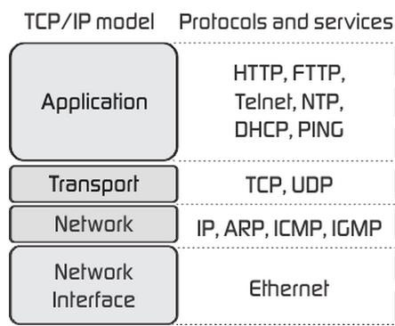

Figure 1.5: TCP/IP Protocol Suite

### 1.9.2.1 The Network Interface layer

The Network Interface layer (also called the Network Access layer) is responsible for placing TCP/IP packets on the network medium and receiving TCP/IP packets off the network medium. TCP/IP was designed to be independent of the network access method, frame format, and medium. In this way, TCP/IP can be used to connect different network types. These include LAN technologies such as Ethernet and Token Ring and WAN technologies such as X.25 and Frame Relay. Independence from any specific network technology gives TCP/IP the ability to be adapted to new technologies such as Asynchronous Transfer Mode (ATM).

The Network Interface layer encompasses the Data Link and Physical layers of the OSI model. Note that the Internet layer does not take advantage of sequencing and acknowledgment services that might be present in the Data-Link layer. An unreliable Network Interface layer is assumed, and reliable communications through session establishment and the sequencing and acknowledgment of packets is the responsibility of the Transport layer.

### 1.9.2.2 Network Layer

The network layer is responsible for addressing, packaging, and routing functions. The core protocols of the Internet layer are IP, IGMP, ICMP and ARP. *The* Internet Protocol (IP) is a routable protocol responsible for IP addressing, routing, and the fragmentation and reassembly of packets. The Address Resolution Protocol (ARP) is responsible for the resolution of the Internet layer address to the Network Interface layer address such as a hardware address.

The Internet Control Message Protocol (ICMP) is responsible for providing diagnostic functions and reporting errors due to the unsuccessful delivery of IP packets. The Internet Group Management Protocol(IGMP) is responsible for the management of IP multicast groups. The Internet layer is analogous to the Network layer of the OSI model.

### 1.9.2.3 Transport Layer

The Transport layer (also known as the Host-to-Host Transport layer) is responsible for providing the Application layer with session and datagram communication services. The core protocols of the Transport layer are Transmission Control Protocol (TCP) and the User Datagram Protocol (UDP). TCP provides a one-to-one, connection-oriented, reliable communications service. TCP is responsible for the establishment of a TCP connection, the sequencing and acknowledgment of packets sent, and the recovery of packets lost during transmission. UDP provides a one-to-one or one-to-many, connectionless, unreliable communications service. UDP is used when the amount of data to be transferred is small (such as the data that would fit into a single packet), when the overhead of establishing a TCP connection is not desired or when the applications or upper layer protocols provide reliable delivery.

The Transport layer encompasses the responsibilities of the OSI Transport layer and some of the responsibilities of the OSI Session layer.

### 1.9.2.4 Application Layer

The TCP/IP model does not have session or presentation layers. No need for them was perceived, so they were not included. Experience with the OSI model has proven this view correct: they are of little use to most applications. On top of the transport layer is the application layer. It contains all the higher-level protocols. The early ones included virtual terminal (TELNET), file transfer (FTP), and electronic mail (SMTP). The virtual terminal protocol allows a user on one machine to log onto a distant machine and work there. The file transfer protocol provides a way to move data efficiently from one machine to another. Electronic mail was originally just a kind of file transfer, but later a specialized protocol (SMTP) was developed for it. Many other protocols have been added to these over the years that includes Domain Name System (DNS) for mapping host names onto their network addresses, NNTP, the protocol for moving USENET news articles around, and HTTP, the protocol for fetching pages on the World Wide Web, and many others.

## 1.9.3 Services of TCP/IP

TCP/IP is a hierarchical protocol made up of interactive modules, each of which provides a specific functionality. The modules are not necessarily interdependent. The OSI model specifies which functions belong to each of its layers. The layers of the TCP/IP protocol suite contain relatively independent protocols that can be mixed and matched depending on the needs of the system. The term hierarchical means that each upper-level protocol is supported by one or more lower-level protocols.

At the transport layer, TCP/IP defines three protocols: Transmission Control Protocol (TCP), User Datagram Protocol (UDP), and Stream Control Transmission Protocol (SCTP). At the network layer, the main protocol defined by TCP/IP is the Internetworking Protocol (IP); there are also some other protocols that support data movement in this layer. The *application layer* in TCP/IP is equivalent to the combined session, presentation, and application layers in the OSI model. Many protocols are defined at this layer, some which are described below.

### 1.9.3.1 Simple Network Management Protocol (SNMP)

It is an Internet Standard protocol for collecting and organizing information about managed devices on IP networks and for modifying that information to change device behavior. Devices that typically support SNMP include cable modems, routers, switches, servers, workstations, printers, and more. The main goal of SNMP is network monitoring for network management tasks. A management information base(MIB) is maintained that contains entries in the form of variables that describe the system status and configuration. Managing applications can query and sometimes even manipulate these variables. It can monitor devices manufactured by different companies working on different physical networks. It specifies the format of message that is exchanged between manager and agents. SNMP frees management tasks from the physical characteristics of devices from the network technologies they use. An important task of SNMP is monitoring or managing a group of agents that is devices through an administrative device also known as *managers*. Each managed system executes a software component called an *agent* which reports information via SNMP to the manager. A network management on the Internet consists of three key components SMI (Structure of Management Information), MIB

(Management Information Base) and SNMP. A typical example of SNMP is shown in Figure

1.6:

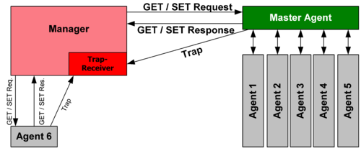

Figure 1.6 Working of SNMP

A *managed device* is a network node that implements an SNMP interface that allows unidirectional (read-only) or bidirectional (read and write) access to node-specific information. Managed devices exchange node-specific information with the NMSs. The types of devices that can be called as managed devices or network elements are switches, routers, cable modems, hubs, bridges, IP video cameras, access servers, computer hosts etc. An *agent* is a networkmanagement software module that resides on a managed device. An agent has local knowledge of management information and translates that information to or from an SNMP-specific form. A *network management station* executes applications that monitor and control managed devices. NMSs provide the bulk of the processing and memory resources required for network management. One or more NMSs may exist on any managed network.

### 1.9.3.2 File Transfer Protocol (FTP)

It is the standard network protocol used for the transfer of computer files between a client and server on a computer network. FTP uses two connections for a pair of client-server machine; one is completely dedicated for data flow while the other is dedicated for control information. FTP users may authenticate themselves with a clear-text sign-in protocol, normally in the form of a username and password. Anonymous connection is also possible with suitable server configuration. For secure transmission that protects the username and password, and encrypts the content, FTP is often secured with SSL/TLS. The first FTP client applications were commandline programs developed before operating systems had graphical user interfaces, and are still shipped with most Windows, Unix, and Linux operating systems. Many FTP clients and automation utilities have been developed for desktops, servers, mobile devices, and hardware, and FTP has been incorporated into productivity applications, such as web page editors.

### 1.9.3.3 Domain Name System (DNS)

The essence of this protocol is in linking URLs with IP address and vise-versa. It is a hierarchical decentralized naming system for computers, services, or other resources connected to the Internet or a private network. It associates various information with domain names assigned to each of the participating entities. The major responsibility of this protocol lies in identifying the unique IP address for a URL that users or humans can remember easily. IP addresses are needed for locating and identifying computer services and devices with the underlying network protocols. By providing a worldwide, distributed directory service, the Domain Name System is an essential component of the functionality on the Internet that has been in use since 1985. An authoritative name server is designated for each domain. DNS outsources the responsibility of assigning domain names and mapping these names to corresponding Internet resources to the authoritative servers. Network administrators may delegate authority over sub-domains of their allocated name space to other name servers. This distribution of responsibilities facilitates distributed and fault tolerant service and avoids a single large central database. The Domain Name System also specifies the technical functionality of the database service that is at its core. It defines the DNS protocol, a detailed specification of the data structures and data communication exchanges used in the DNS, as part of the Internet Protocol Suite. Historically, other directory services preceding DNS were not scalable to large or global directories as they were originally based on text files, prominently the hosts file.

## 1.9.4 Advantages of TCP/IP

TCP/IP is compatible with all operating systems, so it can communicate with any other system.

The internet protocol suite is also compatible with all types of computer hardware and networks. Hence, this is the only protocol used for communication over Internet.

### 1.9.4.1 Standardization

Although computers are capable of exchanging data with each other using several data transfer methods, communication by its very definition requires the transferred information to be understood on the receiving end. A communication protocol is like a language; it enables computers to communicate with each other so that the receiving computer understands the data sent to it. TCP/IP standardizes this communication process by offering one universal protocol for all the computers over the Internet to use in their communication with each other.

### 1.9.4.2 Interoperability

Just as in human communication, computers may use several different languages to communicate with each other. Some protocols may be more suitable for use in certain private networks than TCP/IP. However, TCP/IP enables such networks to be connected to the Internet. Furthermore, it lets computers and devices with different hardware architectures and running different operating systems communicate with each other. This means a computer running Windows can connect to a web server running Linux to browse the website hosted there. It is quite similar to the use of English as an international language today.

### 1.9.4.3 Addressing

TCP/IP assigns each computer on the network a unique address called its IP address. Thus, every computer on the network is uniquely identifiable and information could be sent to it by simply addressing its IP address. The present implementation of IP addressing is known as IPv4, while a newer implementation supporting a much larger number of unique addresses called IPv6 is being developed to replace IPv4.

### 1.9.4.4 Connection

Communication with TCP/IP starts with a connection being established between the two computers. This is achieved in a systematic manner, called the three-way TCP handshake. The computer initiating the communication sends a connection request packet to the other computer. If the computer is the one with the correct IP address, it sends a packet back. If the first computer receives that packet, it sends another one to the second computer, the reception of which by the latter establishes a connection. The information is then exchanged using this established connection, reducing the risk of the data being compromised.

# 1.10 Web Servers

Web servers are dedicated computers that uses HTTP to serve Web pages. Web server has an IP address and a domain name. As by entering URL *http://www.webopedia.com/index.html* in browser, it requests to the Web server having domain name, “***webopedia.com”***. The server in response, fetches the page named *index.html* to the browser.

Any computer can act as web server after installing server software on it. There are many Web server softwares, like public domain software and commercial packages.

## 1.10.1 Web Server Working

Web server responds to the client's request in either of the two ways:

* Attaching the file with the requested URL and sending it to the client.
* Response generation by invoking script and communicating with database The figure below explains the working of a Web server.

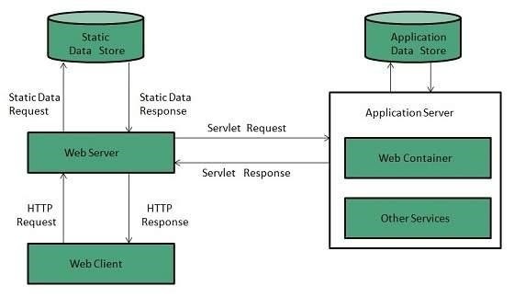

Figure 1.7 Working of Web Server

## 1.10.2 Web Server Architecture

Web Server Architecture follows two approaches:

1. *Concurrent Approach* **-** It can handle multiple client's requests at the same time. This can be achieved by following methods:
   * Multi-process – The incoming request is distributed among multiple single-threaded child processes generated from a single process called parent process.
   * Multi-threaded - Unlike Multi-process, it creates multiple threaded process.
   * Hybrid method - Multiple processes are created and multiple threads are initiated by each process. Each thread handles one connection. It results in less load on system resources.

Leading Web servers include Apache, nginx from NGNIX, Microsoft's Internet Information Server (IIS), IBM's family of Domino servers, Novell's NetWare server, Google Web Server (GWS).

1. *Single-Process-Event-Driven Approach* **-** It uses a single event-driven server process to perform concurrent processing of multiple HTTP requests. It maps a single thread to multiple connections. The thread handles all events occurring from I/O operations of these connections and requests. New events are queued and the thread executes loop-dequeuing events from the queue, process the event, then waits for new events to be pushed.

# 1.11 Web Client

A web client is a program capable of communicating with Web servers, requesting and receiving information from them, and processing it for display or other uses. Web browser is a kind of Web client. The browser at the client computer requests the Web server and the Web server responds the results on the client's computer or other Internet-enabled device that supports a browser. A web page can be requested by just entering a URL into address bar.

Web browser supports text, video, audio, animation etc. files. It is browser's responsibility to interpret commands contained in the web page.

Earlier the web browsers only supported texts but now graphical or voice-based web browsers are also available. The most common web browser available today are:

|  |  |
| --- | --- |
| **Browser** | **Vendor** |
| Internet Explorer | Microsoft |
| Google Chrome | Google |
| Mozilla Firefox | Mozilla |
| Netscape Navigator | Netscape Communications Corp. |
| Opera | Opera Software |
| Safari | Apple |

Table 1.2 Common web browsers available

## 1.11.1 Web Browser Architecture

There are a number of web browsers available in the market. The capability and structure of the browser varies depending upon implementation. The most basic components are listed below:

* Controller/Dispatcher – The working is similar to that of control unit in CPU. It takes input from the keyboard or mouse, translate it and make other services to work based on input it receives.
* Interpreter – After collecting the information from the controller, it executes the instruction line by line. Some interpreters are mandatory (HTML) while some are optional (Java).
* Client Programs – It describes the specific protocols have been designed to access a particular service.

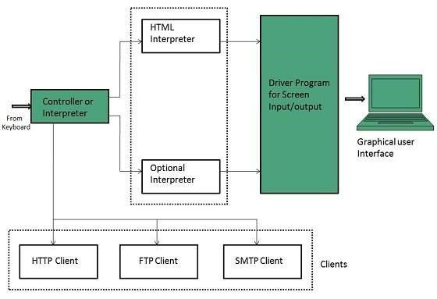

Figure 1.8 Architecture of a web browser

# 1.12 Domain Registration

The Internet Corporation for Assigned Names and Numbers (ICANN) is the non-profit organization that is responsible for the assignment of both IP addresses and domain names. It also procures other tasks like managing root server and TLD name system management. ICANN has contractual agreements with both registries and registrars that provide the foundation for the WHOIS system.

Domain registration is the process of registering a domain name, which identifies one or more [IP addresses](http://www.webopedia.com/TERM/I/IP_address.html) with a name that is easier to remember and use in [URLs](http://www.webopedia.com/TERM/U/URL.html) to identify particular [Web pages.](http://www.webopedia.com/TERM/W/web_page.html) The person or organization who registers the domain name is called as Domain name registrant. The process of registration initializes with applying online to domain registrar or their resellers. The domain name registrant is bound by the terms and conditions of the registrar with which it registers its domain name, for instance adhering to a certain code of conduct or indemnifying the registrar and registry against any legal or civil action taken as a result of use of the domain name. Some of the responsibilities of domain name registrants that are included in the terms and conditions are submission of accurate data, payment of registration fees and timely update of the submitted data.

For domain name to be reachable on the Internet, domain name registrants additionally need to have their domain names listed on name servers. In case the registrar does not offer this service or if the domain name registrant has not opted for the same, he/she has to host his/her own name server.

In some cases, a person or organization who does not wish to have their information listed in WHOIS may contract with a proxy service provider to register domain names on their behalf. In this case, the service provider is the domain name registrant, not the end customer.

ICANN accredits certain organizations that are called as Registrars. These organizations are also certified by the registries to sell domain names. They are bound by the Registrar Accreditation Agreement (RAA) with ICANN, and by their agreements with the registries. The responsibilities for registrar that are imposed by the RAA include:

* maintaining WHOIS data
* submitting data to registries
* facilitating public WHOIS queries
* ensuring domain name registrants details are escrowed
* complying with RAA conditions relating to the conclusion of the domain name registration period

Resellers are the organizations that are affiliated or under contract with registrars. Along with registration they offer other services like web hosting, email mailboxes etc. Resellers are not accredited by ICANN, but are bound by their agreements with the registrar(s) whose services they sell. However, the registrar for whom they are re-selling will still be the sponsor for the domain name registration and accountable for the domain names sold by the reseller.

While registrars are contracted to conduct the day-to-day business of selling domain name registrations, registries are responsible for maintaining the registry for each TLD. The responsibilities of the registries include accepting registration requests (whether from registrars or directly from domain name registrants), maintaining a database of the necessary domain name registration data and providing name servers to publish the zone file data (i.e. information about the location of a domain name) throughout the Internet. A detailed figure representing the registration process is shown below.

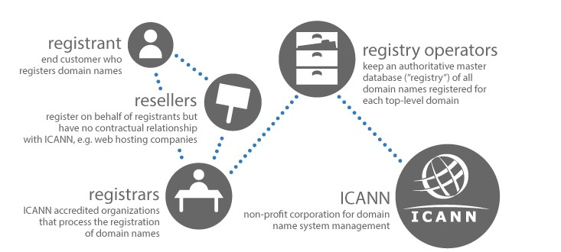

Figure 1.9: Domain Registration Process

# 1.13 Summary

Internet can be viewed as global system of interconnected networks used for sharing resources between computing systems. Internet Standard ensures that hardware and software produced by different vendors can work together. Having a standard makes it much easier to develop software and hardware that link different networks because software and hardware can be developed one layer at a time. The most fundamental of the Internet Standards are the ones defining the Internet Protocol. For transmitting digital data over analog telephone lines modems are used. With the evolution of technology, certain different types of modems such as analog, digital cable (ADSL) and ISDN have been developed. Computers connected to the internet are identified using unique identifiers known as IP address. These addresses are mapped to the names of the computers by the DNS. The name-address mapping is required whenever some data needs to be transmitted between one computer to another. Many technologies exist for connecting to the internet, such as telephone lines, VSAT, RF, etc. The organizations providing the internet services to the users are known as Internet Service Provider (ISP). Internet has a wide range of applications that can be utilized by the users such as, emails, video conferencing, etc.

# 1.14 Questions for Exercise

1. What is Internet? What do you understand by Internet Standards?
2. What are the ways to communicate on Internet?
3. What is TCP/IP? Differentiate Between TCP/IP and OSI Reference model?
4. Explain the TCP/IP model layers and its services?
5. Explain Internet Domain? What is Internet Server Identities?
6. What is Web Server and Web client?
7. What is IP Address? Define classes of IP Address.
8. What is Domain Registration? Explain the steps to register a Domain.

# 1.15 Suggested Readings

* Behrouz A. Forouzan. 2012. Data Communications and Networking, Fifth Edition. New York: the McGraw-Hill Companies Inc.
* William Stallings. 2007. Data and Computer Communications Eighth Edition. New Jersey: Person Education,Inc.
* Douglas E. Comer.2003. The Internet Book. Singapore: Pearson Education Pte. Ltd.

# UNIT- 2: Introduction to HTML

**UNIT STRUCTURE**

2.0 Objective

2.1 HTML

2.2 HTML tags

2.3 Commonly used HTML commands

2.4 Title and footers

2.5 Text formatting

2.6 Text Style

2.7 Lists

2.8 Adding Graphics to HTML documents

2.9 Tables

2.10 Linking Documents

2.11 Frames

2.12 Summary

2.13 Questions for Exercise

2.14 Suggested Readings

# 2.0 Objective

HTML, an acronym for Hyper Text Markup Language, specifies how the structure of a webpage will be with the help of various markups. The following unit explains the core concepts of HTML such as its structure, elements, attributes and core events. It also sheds light on blocklevel elements and text-level elements. With the help of this unit, the reader will be able to understand the basic elements used in HTML and their usage in the formatting of a webpage.

# 2.1 HTML

HTML, an acronym for Hyper Text Markup Language, specifies how the structure of a webpage will be with the help of various markups. It is a structured markup language that is used to create Web pages. Markup languages like HTML bundle together codes which are elements that are used to represent the structure and format of a document. A user agent, usually a Web browser which renders (delivers) the document, interprets the meaning of these codes to decipher (making it into simpler human readable text) how to structure or display a document. The HTML elements are made up of alphanumeric tokens surrounded by angle brackets, for example, <B>, <HTML>, <IMG> and <HR> .

Almost all elements possess a pair of tags i.e. a start tag and an end tag. The start tag is a mnemonic symbol for the element enclosed in ‘<’ ’>’, also known as angle brackets, for instance, the symbol associated with bolding text is B and the start tag for this purpose is <B>. An end tag is the same as that for a start tag, but with an exception that there exists a forward slash preceding the text symbol of start tag: </B>. The instruction applied by an element modifies whatever content is present between the starting and ending tags: This is an example of a simple HTML document.

**Example:**

<! DOCTYPE html>

<html>

<head>

<title>Page Title</title>

</head>

<body>

<h1>It is the First Heading</h1>

<p>It is the first paragraph.</p>

</body>

</html>

**Output:**

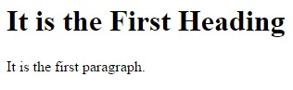

# 2.2 HTML tags

Since HTML is a markup language, therefore, it uses certain tags for formatting the content. The tags are used with angle braces as in <Tag Name>. Leaving few tags, most tags require to be supplemented with closing tags</Tag Name>. As for example, the closing tag of <html> is </html> and the closing tag of <body> is </body>.

HTML document uses the following tags provided in Table 2.1.

|  |  |
| --- | --- |
| **Tags** | **Description** |
| <! DOCTYPE…> | It represents the document type and HTML version. |
| <html> | The HTML document itself begins with <html> and ends with </html> |
| <head> | This tag defines the header of document and it can keep other HTML tags like <title> |
| <title> | The <title> tag is used inside the <head> tag to represent document title |
| <body> | It represents the document’s body which keeps other HTML tags like <h1> |
| <h1> | It defines the heading |
| <p> | This tag represents a paragraph |

Table 2.1 HTML Tags

## 2.2.1 The <!DOCTYPE> Declaration

The <!DOCTYPE> declaration tag is implemented to detect the HTML version used in the document. The contemporary HTML version is 5 which uses the following declaration: <!DOCTYPE html>

There are several declaration types which are used in HTML documents on the basis of HTML version being used. More details will be observed on this during elaboration of <!DOCTYPE...> tag and the remaining HTML tags.

## 2.2.2 Heading Tags

HTML documents begin using a heading. Different sizes can be applied for using headings. HTML features mainly six heading levels using the elements <h1>, <h2>, <h3>, <h3>, <h5>, and <h6>. The web browser inserts one line before and after a heading for fulfilling the purpose of displaying it. Here is an illustrated example.

**Example:**

<!DOCTYPE html>

<html>

<head>

<title> Example of a Heading</title>

</head>

<body>

<h1> Example of heading 1</h1>

<h2> Example of heading 2</h2>

<h3> Example of heading 3</h3>

<h4> Example of heading 4</h4>

<h5> Example of heading 5</h5>

<h6> Example of heading 6</h6>

</body> </html>

**Output:**

**Sample of Heading 1**

**Sample of Heading 2**

**Sample of Heading 3**

**Sample of Heading 4**

**Sample of Heading 5**

**Sample of Heading 6**

# 2.3 Commonly used HTML Commands

## 2.3.1 HEADERS

In HTML, up to six levels of headers are used in any documents, h1 to h6. Header 1 (h1) is the largest header and they get successively smaller through header 6 (h6). Below is an example of <h1> header and how it usually appears in a relation. For rest of the headers we can refer to section 2.2.2 of this book. Here is an example of a <h1> tag.

**Example:**

<h1>Example of a header 1 tag</h1>

**Output:**

EXAMPLE OF A HEADER 1 TAG

## 2.3.2 PARAGRAPHS

The <p> tag provides a means to structure our text into different paragraphs. Each paragraph should write in between an opening <p> and a closing </p> tag as shown below in the example.

**Example:**

<p> it breaks the current line with a trailing blank line

<br>it breaks the current line with no trailing blank line

For our and others *convenience,* it is better to put few blank lines between paragraphs to edit in future or on demand.

## 2.3.3 PREFORMATTED TEXT

The preformatted text tag <pre> used to display the same text in our document as it is written in HTML script. The font-width, their spaces, lines and tabs of our source document remain as is it. In simple words, the browser shows our text as we typed it in. Through monospace font, the text is rendered where the same amount of space is occupied by all characters. Visually, preformatted text looks like a courier font. This is an example of preformatted tag.

**Example:**

<pre>this is a preformatted text tag example</pre>

**Output:**

*this is a preformatted text tag example*

## 2.3.4 BOLDFACE, UNDERLINE AND ITALICS

We can use bold, italic and underline <b>, <i> and <u> tags respectively in HTML editor to highlight the text in a HTML document. The text in-between <b> </b> tags text will be bold and similarly we can apply other two italic and underline. The HTML links do not require extra tag because these are already underlined. The potential for confusion and the archaic nature of underlining in general make it a poor marker for emphasis.

When using these tags, we usually cannot (and probably should not) have text that is both boldface and italics; the last tag encountered is usually the tag that is displayed. For example, if we had a boldface tag followed immediately by an italic tag, the tagged word would appear in italics. This is an example.

**Example:**

<b>boldface</b>

<u> underline</u>

<i>italic</i>

**Output:**

boldface underline

italic

## 2.3.5 LISTS

In HTML, we can give number, unnumbered and lists to the different text using the simple tags. We can also use nested lists with a list. HTML editor automatically takes the space between the bullet or list number in a text, we do not need to mention it. Neither (as yet) do we have control over what type of bullet will be used as each browser is different.

**Unnumbered lists:**

<ul> tag is use to unnumbered any list followed by the actual list items, which are marked with the <li> tag. The list is ended with the ending tag </ul>.

For example, here is an unnumbered list with three items:

**Example disc bullets:**

<!DOCTYPE html>

<html>

<body>

<h2>Disc bullet with Unordered list </h2>

<ul style="list-style-type:disc">

<li>Ram</li>

<li>Shyam</li>

<li>Mahesh</li>

</ul>

</body>

</html>

**Output disc:**

|  |  |
| --- | --- |
| • | Ram |
| • | Shyam |
| • | Mahesh |

**This is an example of a circle bullet.**

**Example circle bullets:**

<!DOCTYPE html>

<html>

<body>

<h2>Circle bullets with Unordered list </h2>

<ul style="list-style-type:circle">

<li>Ram</li>

<li>Shyam</li>

<li>Mahesh</li>

</ul>

</body>

</html>

**Output:**

|  |  |
| --- | --- |
| o | Ram |
| o | Shyam |
| o | Mahesh |

**This is an example of a square bullet.**

**Example square bullet:**

<!DOCTYPE html>

<html>

<body>

<h2> Square Bullets with Unordered list </h2>

<ul style="list-style-type:square">

<li>Ram</li>

<li>Shyam</li>

<li>Mahesh</li>

</ul>

</body> </html> **Output:**

|  |  |
| --- | --- |
| ▪ | Ram |
| ▪ | Shyam |
| ▪ | Mahesh |

### Numbered lists

Similar example given here using a numbered list format:

**Example Numbers:**

<!DOCTYPE html>

<html>

<body>

<h2>Numbers are used for Ordered List</h2>

<ol type="1">

<li>Ram</li>

<li>Shyam</li>

<li>Mahesh</li>

</ol>

</body>

</html>

**Output:**

1.

Ram

2.

Shyam

3.

Mahesh

This is an example of an uppercase letter use in list.

**Example Uppercase Letters:**

<!DOCTYPE html>

<html>

<body>

<h2>Letters are used for Ordered List </h2>

<ol type="A">

<li>Ram</li>

<li>Shyam</li>

<li>Mahesh</li>

</ol>

</body>

</html>

**Output:**

A.

Ram

B.

Shyam

C.

Mahesh

This is an example of a lowercase letter use in list.

**Example Lowercase Letter:**

<!DOCTYPE html>

<html>

<body>

<h2> Lowercase Letters are used for Ordered List </h2>

<ol type="a">

<li>Ram</li>

<li>Shyam</li>

<li>Mahesh</li>

</ol>

</body>

</html>

**Output:**

1. Ram
2. Shyam
3. Mahesh

This is an example of roman letters.

**Example Roman letters:**

<!DOCTYPE html>

<html>

<body>

<h2> Roman Numbers are used for Ordered List </h2>

<ol type="I">

<li>Ram</li>

<li>Shyam</li>

<li>Mahesh</li>

</ol>

</body>

</html>

**Output:**

I.

Ram

II.

Shyam

III.

Mahesh

## 2.3.6 BLOCKQUOTE

For a long quotation in the text, we can use a < blockquote > tag and the text enclosed within this tag indicates an extended quotation. Blockquote texts are generally rendered by the browser as indented text. It looks like this:

<blockquote>...</blockquote>

## 2.3.7 HORIZONTAL LINE

We can insert a horizontal rule tag <hr> to separate a paragraph into different sections. A horizontal rule line is displayed as shown below:

This is an example of a horizontal line

This is an example of a horizontal line

# 2.4 Title and footers

## Title definition and Usage

The <title> is an important tag which required to shown the title of the HTML documents and it only contains text and other tags containing in the title are ignored. The title is displayed in the browser’s toolbar. It also shows the favorite pages title which we added during browsing and in search-engine results title.

This is an illustrative example of title tag.

**Example:**

<!DOCTYPE html>

<html>

<head>

<title> First HTML script for web page </title>

</head>

<body>

First HTML script for web page

</body> </html>

**Output:**

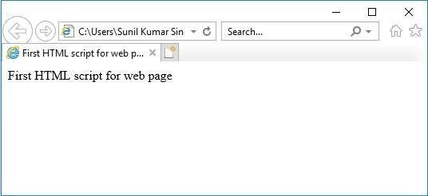

## Footer definition and Usage

The <footer> tag in HTML represents a footer for a document or section. A <footer> element generally contains information about its author, copyright data or links to other related documents. You can have several <footer> elements in one document.

This is an example of a footer.

**Example:**

<!DOCTYPE html>

<html>

<body>

<footer>

<p>Posted by: xyz</p>

<p>Contact information: <a href="mailto:xyz@yahoo.com">xyz@yahoo.com</a>.</p> </footer>

<p><strong>Note:</strong> The footer tag is supported only from Internet Explorer 9 and later versions.</p>

</body> </html>

**Output:**

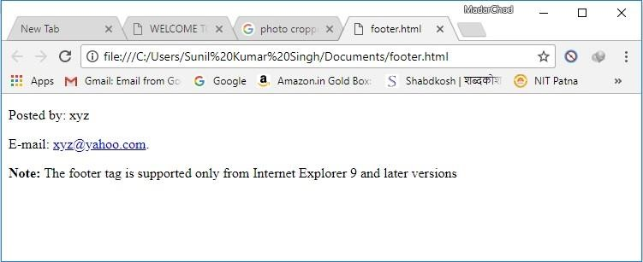

# 2.5 Text Formatting

The text formatting tags are used to change the appearance of some text so that it looks different from normal text in web pages. Several formatting tags are consists in HTML to format the text, like <i>, <em> etc.

The following HTML tags can be used to display special types of text:

* <ins> - Inserted text
* <del> - Deleted text
* <i> - Italic text
* <b> - Bold text
* <small> - Small text
* <em> - Emphasized text
* <strong> - Important text
* <mark> - Marked text
* <sub> - Subscript text
* <sup> - Superscript text

## 2.5.1 HTML <b> and <strong> Elements

The HTML **<b>** tag displays **bold** text, without any extra importance.

**Example:**

<!DOCTYPE html>

<html>

<body>

<p> Example of a simple text.</p>

<p><b> Example of a bold text.</b></p>

</body>

</html>

**Output:**

Example of a simple text

**Example of a bold text.**

## 2.5.2 HTML <i> and <em> Elements

The HTML **<i>** tag represents *italic* text, without any extra importance.

<!

DOCTYPE html

>

>

html

<

>

body

<

<

p>Example of a simple text.</p

>

<

p><i>Example of a italic text.</i></p

>

<

/body

>

<

/html

>

**Output:**

Example of a simple text.

*Example of italic text.*

## 2.5.3HTML <small> Element

The HTML **<small>** tag defines smaller text:

**Example:**

<!DOCTYPE html>

<html>

<body>

<h2>HTML <small>Small</small> Formatting</h2>

</body>

</html>

**Output:**



### 2.5.4 HTML <mark> Element

The HTML **<mark>** tag defines marked or highlighted text:

**Example:**

<!DOCTYPE html>

<html>

<body>

<h2>HTML <mark>Marked</mark> Formatting</h2>

</body>

</html>

**Output:**



The HTML <del> tag used to highlight the deleted (removed) text.

**Example:**

<!DOCTYPE html>

<html>

<body>

<p>The del tag defines deleted (removed) text.</p>

<p>I like to play <del>Cricket</del> Football.</p>

</body>

</html>

**Output:**

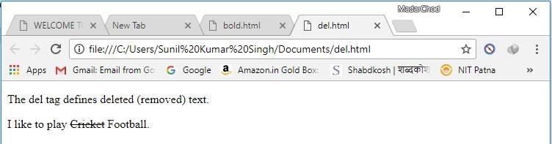

# 2.6 Text Style

The appearance of an HTML page can be changed with the **style attribute**. The ***syntax*** of the HTML style attribute is given below:

*<tagname style="property:value;">*

The ***property*** is a CSS property (Cascading Style Sheet, used for enhancing the look of any document). The ***value*** is a CSS value.

## 2.6.1 HTML Background Color

We can set the background color of any HTML page by using the **background-color** property. The below example shows how to set the background color of a page to powder blue:

**Example:**

<!DOCTYPE html>

<html>

<body style="background-color:powderblue ;">

<h1>Example of Background Color changing.</h1>

<p>Example of Background Color changing.</p></body> </html>

**Output:**

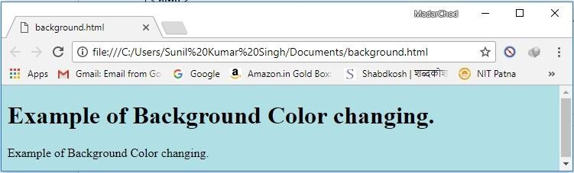

## 2.6.2 HTML Text Color

The text color of an HTML page can be change by using color property which is shown below with an example.

**Example:**

<!DOCTYPE html>

<html>

<body>

<h1 style="color:blue;">Example of Blue color text.</h1>

<p style="color:red;">Example of Red color text.</p>

</body>

</html>

**Output:**

*Example of Blue color text.*

*Example of Red color text.*

## 2.6.3 HTML Text Size

The size of the font in a HTML document can be set according to our requirement by using **fontsize** property and it is illustrated below with a simple example:

**Example:**

<!DOCTYPE html>

<html>

<body>

<h1 style="font-size:300%;">The font size is very large.</h1>

<p style="font-size:160%;">The font size is big.</p>

<p style="font-size:60%;">The font size is small.</p>

</body>

</html>

**Output:**

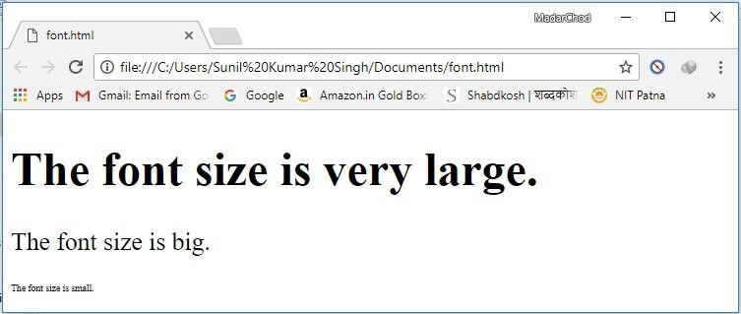

## 2.6.4 HTML Text Alignment

For alignment of the text of HTML pages, there are four **text-align** property (left, center, right and justify) that are frequently used. It defines the horizontal text alignment for an HTML element. The example given below shows the method for center alignment text:

**Example:**

<!DOCTYPE html>

<html>

<body>

<h1 style="text-align:center;">Centered Heading</h1>

<p style="text-align:center;">Centered paragraph.</p>

</body>

</html>

**Output:**



### 2.6.5 Changing a paragraph's background color

Here is an example of background color

**Example:**

<p style = "background-color: green">

The background color of the Paragraph is Green.

</p>

**Output:**

|  |  |  |
| --- | --- | --- |
|  | *The background color of the Paragraph is Green.* |  |

### 2.6.6 Changing foreground and background color

Here is an example of foreground and background color **Example:**

<p style = "color: blue";

“background-color: green”>

<p style “text-color: blue”; The text is Blue on a Green background color> </p>

**Output:**

|  |  |  |
| --- | --- | --- |
|  | *The text is Blue on a Green background color* |  |

### 2.6.7 Changing Font Family

Here is an example of comic sans family

**Example:**

|  |
| --- |
| *<p style = "font-family: Comic Sans MS, Cursive">*  *This paragraph is in Comic Sans </p>* |

**Output:**

This paragraph is in Comic Sans

### 2.6.8 Changing Font Size

Here is an example for font size 30.

**Example:**

<p style = "font-size: 30pt">

This paragraph is in 30 pts

</p>

**Output:**

# *This paragraph is in 30 pts*

## 2.7 Adding Graphics to HTML Document

In the beginning, graphics was not supported by the web pages only texts are used. But later on images and other types of multimedia files are embedded with web pages. The graphics are embedded in a HTML pages using a simple tag which is represented by <IMG>. We can also embed the images inside other elements such as anchors. When embedded inside an anchor, then the user left clicks on the image, they will go to the designated link (rather, their browser will load a file from the designated link). The <IMG> element has no ending tag. The syntax of embedding an image is follows:

<img src=”tree.jpg”>

Here, src attributes defines a path pointing to the image from where we want to embed.

### IMG Attributes

|  |  |  |
| --- | --- | --- |
| **Sr. No.** | **IMG Attributes** | **Function of attributes** |
| 1. | ALT="Home" | Image not found massage shows. |
| 2. | ALIGN="TOP" | Set image alignment like left, right, top, bottom etc. |
| 3. | VSPACE=3 | Upper and lower space in pixels of an image between texts. |
| 4. | HSPACE=5 | Left and right space in pixels of an image between texts. |
| 5. | BORDER=10 | Set a border around the image with a specific width. |
| 6. | HEIGHT=33 | Set image height based on the browser height. |
| 7. | WIDTH=115 | Set image width based on the browser height. |
| 8. | ISMAP | It represents image map and user can point and click different parts of the image to load other web pages. |
| 9. | USEMAP | Specifies the client side image map file to be used. |

Table 2.1 Image Attributes

The line break element, <BR> and the horizontal rule element <HR> may be placed inside the <IMG> element.

An example of adding an image source. **Example:**

<img src=”funny dog.jpg” alt=”funny dog sitting”.>

**Output:**

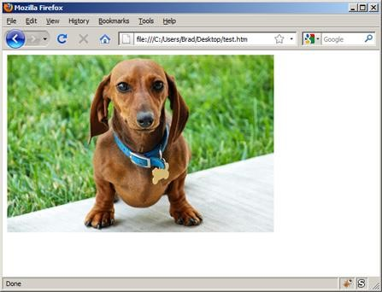

**2.8**

**Tables**

### 2.8.1 Defining an HTML Table with Border

An HTML <table> tags are used to create different table in our web pages. Each table row is defined with the **<tr>** tag. A table header is defined with the **<th>** tag. By default, table headings are bold and centered. A table data/cell is defined with the **<td>** tag. This is an example of HTML table with border where border width is 1.

**Example:**

<!DOCTYPE html>

<html>

<Body>

<table border="1">

<tr>

<th>Student Name</th>

<th>Subject</th>

<th>Marks</th>

</tr>

<tr>

<td>Ram</td>

<td>HTML</td>

<td>87</td>

</tr>

<tr>

<td>Shyam</td>

<td>HTML</td>

<td>73</td>

</tr>

</table>

<Body> </html>

**Output:**

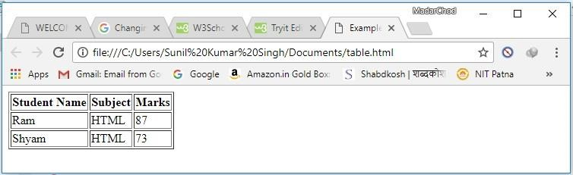

**2.8.2 Html Table Tags:**

|  |  |
| --- | --- |
| Tag | Description |
| <table> | Displays a table |
| <th> | Represents a header cell in a table |
| <tr> | A row in a table |
| <td> | A cell in a table |
| <col> | Specifies column properties for each column within a <colgroup> element |
| <caption> | A table caption |
| <colgroup> | Specifies a group of one or more columns in a table for formatting |
| <thead> | Groups the header content in a table |
| <tbody> | Groups the body content in a table |
| <tfoot> | Groups the footer content in a table |

Table 2.2 Table Tags

### 2.8.3 HTML Table without Border

If we want to create table without border, it will be created by not defining border size. This is an example of a table without border.

**Example:**

<html>

<body>

<table style="width:100%">

<tr>

<th>Student Name</th>

<th>Subject</th>

<th>Marks</th>

</tr>

<tr>

<td>Ram</td>

<td>HTML</td>

<td>87</td>

</tr>

<tr>

<td>Shyam</td>

<td>HTML</td>

<td>73</td>

</tr>

<tr>

<td>Ghanshyam</td>

<td>HTML</td>

<td>67</td>

</tr>

</table>

</body>

</html>

**Output:**

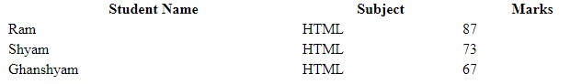

### 2.8.4 HTML Table - Adding Cell Padding

To manage the spaces between the cell of a table and its border, we use Cell padding tags. If we do not mention a padding, the table cells will be displayed without padding. This is an example of a cell padding.

**Example:**

|  |
| --- |
| <!DOCTYPE html>  <html>  <head> <style> table, th, td { border: 1px solid black; border-collapse: collapse;  } th, td {  padding: 20px;  }  </style>  </head>  <body>  <table style="width:100%">  <tr>  <th>Student Name</th>  <th>Subject</th>  <th>Marks</th>  </tr>  <tr>  <td>Ram</td>  <td>HTML</td>  <td>87</td>  </tr> |

<tr>

<td>Shyam</td>

<td>HTML</td>

<td>73</td>

</tr>

<tr>

<td>Ghanshyam</td>

<td>HTML</td>

<td>67</td>

</tr>

</table>

<p>Try to change the padding to 15px.</p>

</body>

</html>

**Output:**

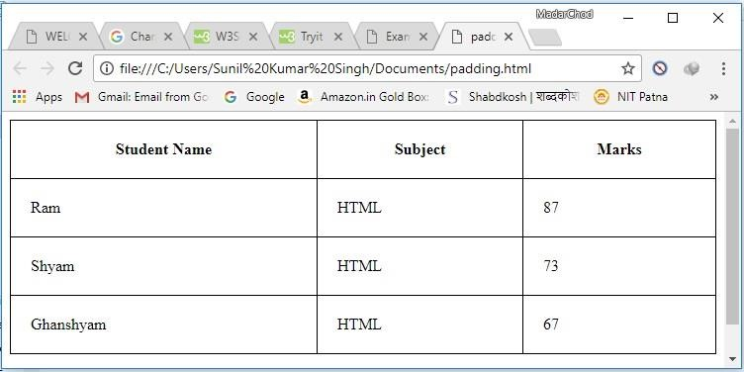

## 2.9 Linking Documents

### HTML Links – Hyperlinks

In a web page, several links are used to directly access the other pages or other parts of a given page. These links are also known as hyperlinks which allows user to switch between different web pages. When we move the mouse over a link, the mouse arrow will turn into a little hand.

**Note:** A link does not have to be text. It can be an image or any other HTML element.

### Other tags

* **<a>** tag is an anchor tag which represents a link to reach the new linked document.
* **href** attribute is used to link the address of the web pages by url.
* **target** attribute to define where to open the linked document
* **<img>** tag (inside <a>) to use an image as a link
* **id** atribute (id="*value*") to show a bookmarks in web page
* **href** attribute (href="#*value*") to link to the bookmarks

<a href="/html/default.asp">HTML tutorial</a>

This is an example of a hyperlink.

**Example:**

<!DOCTYPE html>

<html>

<body>

<p><a href="https://www.google.com">Visit google website</a></p>

</body>

</html>

**Output:**

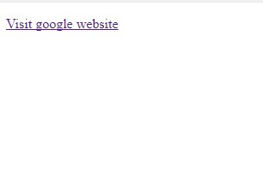

## 2.10 Frames

In HTML pages, frames allow multiple views to the user and we can browse window into multiple sections with a separate HTML document. A browser contains many frames in a window which is known as a frameset. The window frames are divided into rows and columns in similar way as table are organized.

### Disadvantages of Frames

Due to some major drawbacks of frame in window, it is never recommended to use frames in our webpages −

* In smaller screen, frames do not cop-up properly because their screen is not big enough to be divided up.
* Sometimes our page will be displayed differently on different computers due to different screen resolution.
* The browser's *back* button might not work as the user hopes.
* There are still few browsers that do not support frame technology.

### Creating Frames

To use frames on a page we use <frameset> tag instead of <body> tag. The <frameset> tag defines how to divide the window into frames. The **rows** attribute of <frameset> tag defines horizontal frames and **cols** attribute defines vertical frames. Each frame is indicated by <frame> tag and it defines which HTML document shall open into the frame.

## 2.11 Summary

HTML is a structured programming language (Structured programming is paradigm aimed at improving the clarity, quality, and development time of a computer program) which provides a set of rules for correct application of elements. The browser renders (display) the HTML code for correct representation and orientation of content. At times, the rules laid down in HTML are interpreted differently by browser which provides the programmers an opportunity to exploit this vulnerability. HTML is essentially a tag-based language. The documents start with the <! DOCTYPE> tag. The entire document is encapsulated within <HTML> (opening and closing) tags. The document is further divided into header and body sections specified by <HEAD> and <BODY> tags, respectively. The header section is used to provide the descriptive information related to the web document and needs to contain the <TITLE> tag to define the title of the page. The body section of the web document contains information regarding placement of various elements of the document. Block-level elements, text-level elements, and special-character entities are used to structure it. Some tags are used for providing certain logic and the others are for physical representation. The HTML elements discussed so far are of basic nature and are widely used over all systems. They are utilized to customize the document presentation. However, a complete look of the web document cannot be achieved simply using these basic tags.

## 2.12 Questions for Exercise

1. Define HTML Tag and list a few basic tags used in HTML.
2. What is a list? Why do we use them?
3. What are the different types of lists used?
4. Why bold and italic tags are used? Illustrate using suitable example.
5. How do we create frames? What are the disadvantages of using frames?
6. Show with an example the use of different heading types.
7. How to assign different colors in a HTML document?

## 2.13 Suggested Readings

* Behrouz A. Forouzan. 2012. Data Communications And Networking, Fifth Edition. New York: the McGraw-Hill Companies Inc.
* William Stallings. 2007. Data And Computer Communications Eighth Edition. New Jersey: Person Education,Inc.
* Douglas E. Comer.2003. The Internet Book. Singapore: Pearson Education Pte. Ltd.
* M.Srinivasan. 2012. Web Technology Theory and Practice. India: Dorling Kindersley Pvt.Ltd.
* Raj Kamal. 2006. Internet and Web Technologies. India: The Tata McGraw-Hill Publishing Company Limited.

**Activity Question with Solution**

Q 1 : Develop static pages (using only HTML) of an online Book store. The

pages should resemble: www.amazon.com. The website should consist

the following pages.

* Home page
* Registration and user Login
* User profile page
* Books catalog
* Shopping cart
* Payment by credit card Order Conformation

PROCEDURE:

• Home page

**Main.html:**

<html>

<head>

<title>

Amazon</title>

</head>

<body bgcolor="cyan"> <center>

<strong><h1>Welcome to AMAZON</h1></strong>

<form method="post" action="login.html" target=_blank >

<h4>for books</h4><input type="submit" value="click here">

</form>

</center>

</body>

</html>

**• Registration and user Login**

**Login.html:**

<html>

<head>

<title>

login page</title>

</head>

<body bgcolor="cyan"> <center>

<strong><h1> AMAZON </h1></strong></center>

<right>

<table align="right">

<tr>

<td><h4>user name</td>

<td><input type="text" ></td>

<td></td>

</tr>

<tr>

<td><h4>password</td>

<td><input type="password"></td>

<td></td>

</tr>

<tr>

<td>

<form method="post" action="catalog.html" >

<input type="submit" value="submit" >

</form>

</td>

<td>

<form method="post" action="userpro.html" >

<input type="submit" value="register" >

&nbsp;&nbsp;

<input type="reset" value="reset"></form></td>

</tr>

</table>

</body>

</html>

**• User profile page**

**Userpro.html:**

<html>

<head>

<title>

login page</title>

</head>

<body bgcolor="cyan">

<center><strong><h1> AMAZON </h1></strong></center>

<form method="post" action="catalog.html" > <right>

<table align="left">

<tr>

<td><h4>user name</td>

<td><input type="text" ></td>

<tr>

<tr>

<td><h4>password</td>

<td><input type="password"></td>

</tr>

<tr>

<td><h4>confirm password</td>

<td><input type="password"></td>

</tr>

<tr>

<td><h4>male &nbsp;&nbsp;

<option >

<input type="radio" name="sex"

id="male"></td> <td><h4>female &nbsp; &nbsp;

<input type="radio" name="sex" id="female" ></td>

</option></tr>

<tr>

<td>Address</td>

<td><textarea name="address" rows=5 cols=19>

</textarea>

</td>

<tr>

<td>

<input type="submit" value="submit" ></td>

<td>

<input type="reset" value="reset"></td>

</tr>

</form>

</body>

</html>

**• Books catalog**

**Catalog.html:**

<html>

<head>

<title>

books catalog</title>

</head>

<body bgcolor="cyan">

<center><h1>AMAZON</h1></center>

<form method="post" action="shopping.html">

<left>

<table>

<tr>

<td><b><h3>frontend books</td>

<td></td></tr>

<tr>

<td></td>

<td><h4>C&Ds</td>

</tr>

<tr>

<td></td>

<td><h4>Ads</td>

</tr>

<tr>

<td></td>

<td><h4>JAVA

</td></tr>

<tr>

<td><b><h3>backend books</td>

<td></td>

</tr>

<tr>

<td></td>

<td><h4>Oracle</td>

</tr>

<tr>

<td></td>

<td><h4>Ms SQL Server

</td></tr>

<tr><td></td>

<td><h4>MySql </td>

</tr>

</table>

</h4>

<center>

<b>for buy one of these books

<br>

</b><input type="submit" value="click here">

</center>

</form>

</body>

</html>

**• Shopping cart**

**Shopping.html:**

<html>

<head><title>shopping cart</title>

</head>

<body bgcolor="cyan">

<center><h1>

Shopping Cart</h1></center>

<br><br><br><br><br>

<table align="center">

<tr>

<td>Text Books</td>

<td>

<select >

<optgroup label="select the book">

<option value="C&Ds">C&Ds

<option value="Ads">Ads

<option value="Java">Java

<option value="Oracle">Oracle

<option value="Ms SQL Server">Ms SQL

Server <option value="MySql">MySql

</optgroup>

</select>

</td></tr>

<tr>

<td>

Quantity</td>

<td>

<input type="text" id="q">

</td></tr>

<tr>

<td></td>

<td>

<form method=post action="payment.html">

<input type="submit" value=ok />

</form>

</td></tr>

</table>

<center>

<pre>Cost of one book is"500" + shipping "100"</pre>

</center>

<body>

</html>**• Payment by credit card**

**Payment.html:**

<html>

<head><title>payment</title></head>

<body bgcolor="cyan">

<center><h1>Payment By Credit Card</h1></center>

<form method=post action="ordrconform.html">

<br><br><br><br><br>

<table align="center">

<tr>

<td>

<h4>Total Amount</h4></td>

<td><input type="text">

</td>

</tr>

<tr>

<td><h4>Credit Card Number</td>

<td><input type="text"></td>

</tr>

<tr>

<td>

</td>

<td><input type="submit" value=OK>

</td>

</tr>

</table>

</form></body>

</html>

**• Order Conformation**

**Ordrconform:**

<html>

<head><title>order conformation</title><M/head>

<body bgcolor="cyan">

<center>

<h1><b>BOOK SHOPPING</h1>

<pre><strong>

<b>Your order Is Conformed

</strong></pre>

<h2><b>THANK YOU</h2>

</center>

</body></html>

Q2: Design this following page:

